Municode Website instructions

Municode Website Instructions
The new and improved Municode site allows you to navigate to, print, save, e-mail and link to desired sections of the Online Code of Ordinances with greater efficiency. Listed below are examples of the improved features within the Municode website and how-to instructions on using these features. Click on a link below to navigate to that particular feature or scroll to read the entire document.
Navigation
- Viewing information from a table of contents
- Expanding folders within a table of contents
- Navigate using the ‘bread crumb trail’
Search
- Entering search criteria
- Narrowing your search range
Print
- Printing a portion of the online code (an easy three-step process)
Saving
- Saving a portion of the online code
Sending codes by e-mail
- E-mailing a portion of the online code
Linking to the code
Creating a static URL link to any heading level of the online code

Navigation
- Click the title of a folder to view the information contained within that folder:
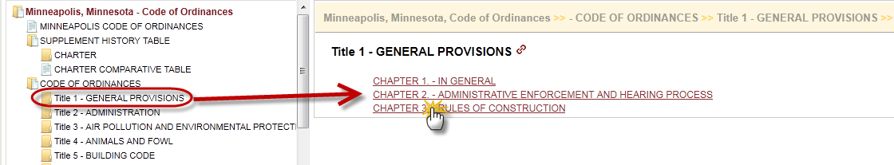
- Either double clicking the folder title OR single clicking the folder icon will expand the folder to show its contents within the left side Table Of Contents:
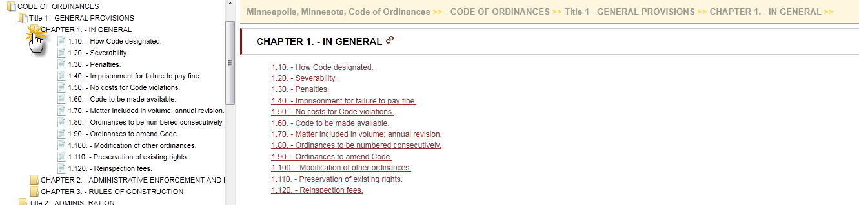
- You can navigate back to a previous point of the Code by using the “Bread Crumb Trail” located at the top of the content pane on the right side:
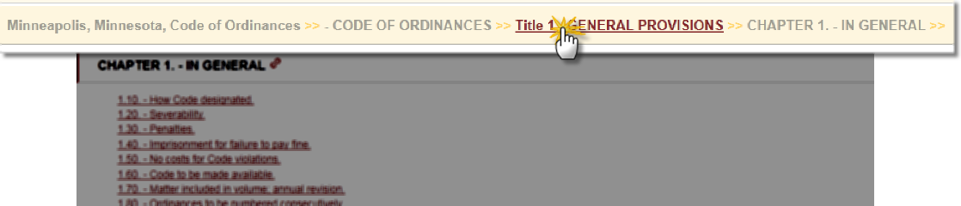
<Back to the top>

Search
How to enter search criteria to find an ordinance(s):
- Enter a word, phrase, or section number in the search box at the top of the page (see illustration) and click Go.
- Your hit list will display in the body of the content frame on the right.
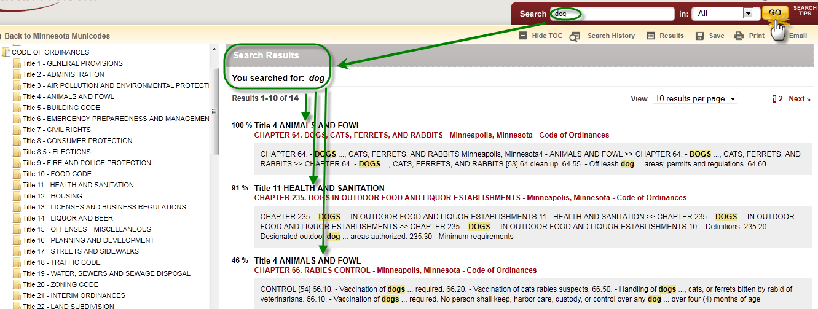
To narrow your search range:
- Choose ‘Selected’ in the drop down menu next to the Go button.
- Select the ordinance folder(s) in the left hand navigational column you want to search in by placing a check(s) in the box next to the folder.
- Click on Go to get more specific results.
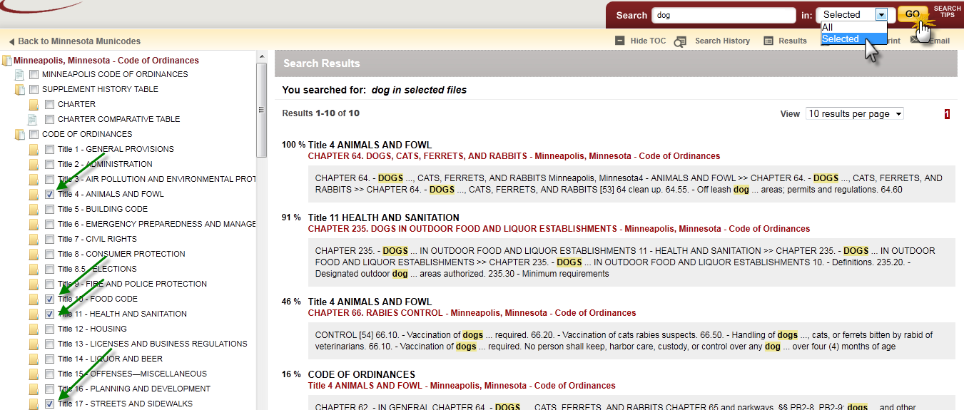
<Back to the top>

Printing
Printing a portion of the online Code:
- Navigate to the chapter you wish to print from and click on Print in the feature button selection bar on the upper right hand corner of the page just under the search bar (see graphic below). Then proceed to next bullet point …
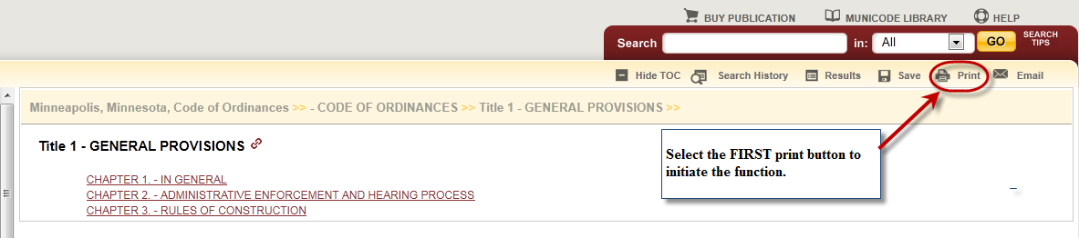
- Put a check in the box next to the part of the Code you wish to print.
- Remove any pop-up blocking for this page from your browser tools – often you will see an ‘alert’ bar at the top of your page asking if you wish to permit a pop-up from the site.
Microsoft Windows Internet Explorer: To disable the pop-up blocker while on the site, open the Tools menu, select the Pop-up Blocker option, and select the Turn Off Pop-up Blocker option (as shown below):
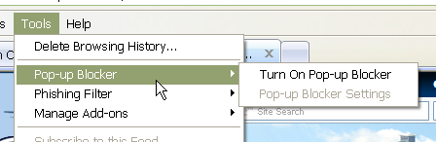
Once this is done, then you should be able to use the online system properly. Once you are finished using the online system, you can go back into the menu again to turn on the pop-up blocker. Or, you may also see an optin that you can select allowing pop-ups from our website specifically.
- Select the items you wish to print by placing a check in the box before the title. Unchecking the first box at the top next to the title in bold will remove ALL of the checks allowing you to select individual items more quickly. Click on the second Print button located just above the check boxes (see graphic below).
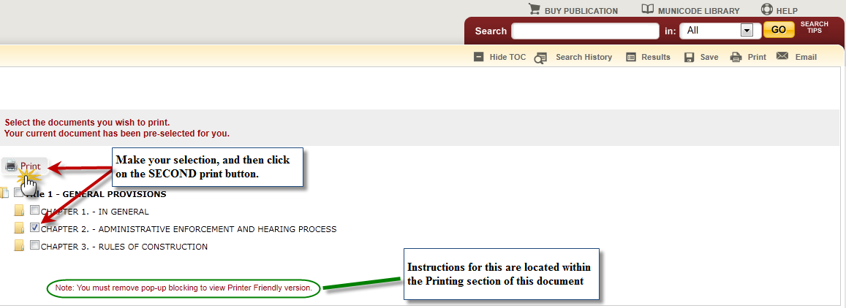
- A new tab, or window will open with a ‘print preview’ page showing what you are about to print. Click on the third and final Print button (see graphic below). Now you can complete the request using your computer’s printing options.
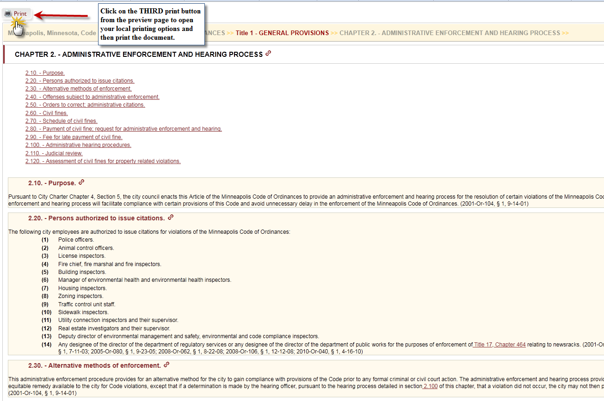
<Back to the top>

Saving
To save a portion of the online Code:
- Navigate to the part of the code you wish to save and click on Save in the button bar on the upper right hand corner of the page.
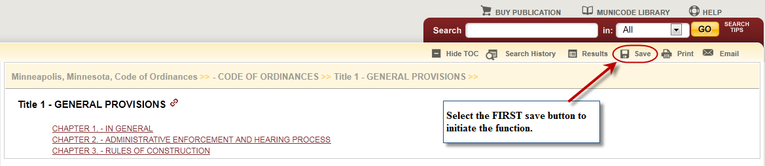
- Select the items you wish to save by placing a check in the box before the title. Unchecking the first box at the top next to the title in bold will remove ALL of the checks allowing you to select individual items more quickly. Click on the second Save button located just above the check boxes (see graphic below).
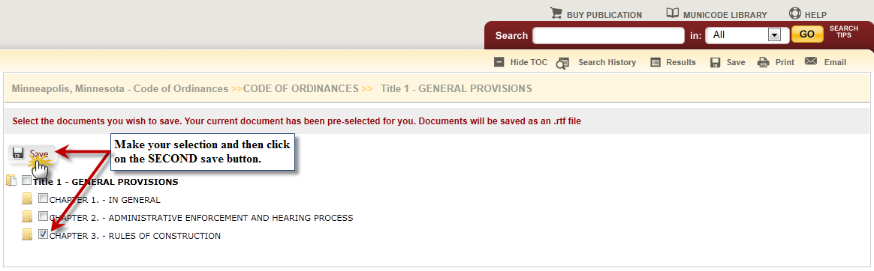
- Save documents to a predetermined site by clicking the save button and then selecting the location, or open it from here. (Documents will be saved in rich text format - RTF)
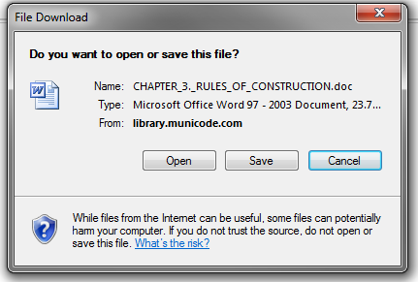
<Back to the top>

E-mail the Code
To e-mail a portion of the online Code:
- Navigate to the chapter you wish to e-mail from and click on Email in the button bar on the upper right hand corner of the page.
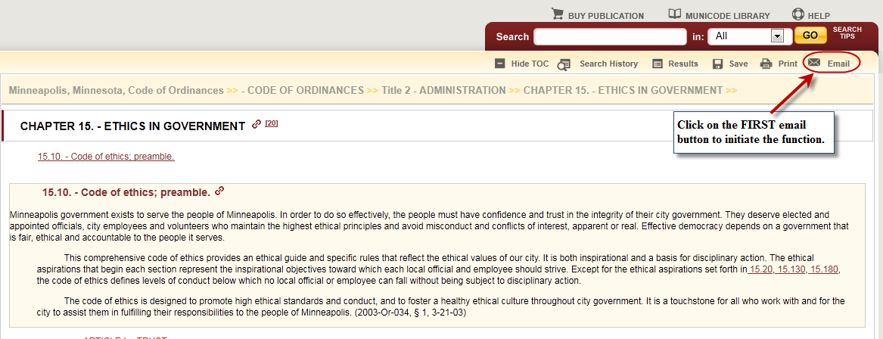
- Place a check mark in the boxes next to the document(s) you wish to e-mail. Then click the second Email button.
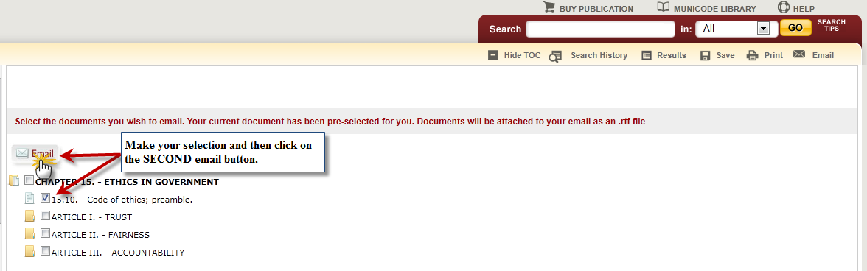
- Fill out the required fields – subject and message body are optional
- Click Send.
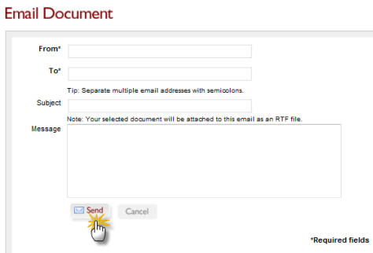
<Back to the top>

Linking
Creating a static URL link to any heading level of the online Code
- Navigate to the desired Title, Chapter, Division, Article, or Section you wish to create a static web link to. Click on the title when your cursor turns into a hand and you see the “copy to clipboard” message appear. (see below).
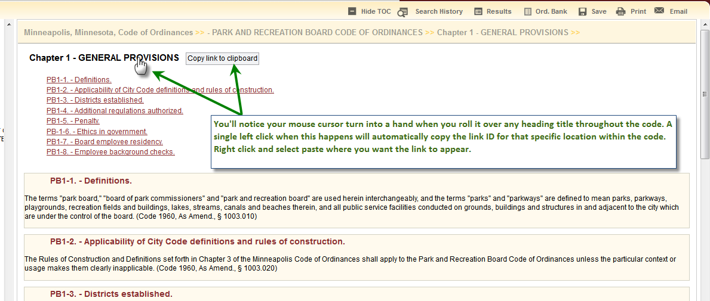
- The URL will automatically be copied to your computers *clipboard, or temporary memory.
- Paste (Ctrl V, or right click and select paste) where you want to place the URL link.
- Once pasted, and added to the location you choose as a hyperlink, You will be taken directly to that heading title when you click on it.
- This feature does not carry any of the other web page frames with it. It will not carry over the left side table of contents, nor will it carry over the search function, or any other tools. It creates a direct link to the content only.
* Clipboard: The clipboard is a software facility that can be used for short-term data storage and/or data transfer between documents or applications, via copy and paste operations. It is most commonly a part of a GUI environment and is usually implemented as an anonymous, temporary block of memory that can be accessed from most or all programs within the environment via defined programming interfaces.

<Back to the top>

